­­­­­­­­­­­­­­­­­­­­­­­­­­­­­­­­­­­­­­­­INTRODUCTION

* 1. **Language Name:** TWT Language

Formal/Official/Long name: The Wanna Tweet Language

The programming language we created is inspired from the famous social networking website Twitter. The syntax, the rules, and terms mostly came from the said application. The programming paradigm of this language is Imperative for it is straight forward and just simply follows the expression given line by line.

* 1. **Grammar Definition**

<Program> -> <Declaration> <Main>

| <Main>

<Declaration> -> <Dtype> <Vname> "(" <Args> ")" "{" <Block> <Return>"}"

| <Dtype> <Vname> "(" <Args> ")" "{" <Block> "}"

<Main> -> "LOGIN" <Block> "LOGOUT"

| "LOGIN" "LOGOUT"

<Block> -> <State> // Block is made up of statement <State> of the same level

<State> -> <Loop> "#" <StatePrime>

| <If> "#" <StatePrime>

| <Assignment> "#" <StatePrime>

| <Call> "#" <StatePrime>

| <Printing> "#" <StatePrime>

| <Control> "#" <StatePrime>

<StatePrime> -> <Loop> "#" <StatePrime>

| <If> "#" <StatePrime>

| <Assignment> "#" <StatePrime>

| <Call> "#" <StatePrime>

| <Printing> "#" <StatePrime>

| <Read> "#" <StatePrime>

| <Control> "#" <StatePrime>

<Loop> -> "RT" <Boolean> {" <Block> "}"

<If> -> "IF" <Logic> "FOLLOW" "{" <Block> "}" <ElseIf> <Else>

| "IF" <Logic> "FOLLOW" "{" <Block> "}" <Else>

| "IF" <Logic> "FOLLOW" "{" <Block> "}"

<ElseIf> -> "ELSEIF" <Logic> "FOLLOW" "{" <Block> "}" <Elseif>

<Else> -> "ELSE" <Logic> "FOLLOW" "{" <Block> "}"

<Assignment> -> <DType> <Vname> "=" <Vname>

|<DType> <Vname> "=" <Reading>

|"@INT" <Vname> "=" <INT>

| "@CHIRP" <Vname> "=" <CHAR>

| "@COKE" <Vname> "=" <FLOAT>

| "@MSG" <Vname> "=" <STRING>

| "@TRALSE" <Vname> "=" <BOOL>

| <DType> <Vname> "=" "(" <Exp> ")"

<Call> -> <Vname> "(" <Args> ")"

<Printing> -> "TWEET" <Vname>

| "TWEET" <EXP>

| "TWEET" <INT>

| "TWEET" <FLOAT>

| "TWEET" <CHAR>

| "TWEET" <STRING>

| "TWEET" <BOOL>

<Reading> -> "REPLY" <Vname>

| "REPLY" <EXP>

| "REPLY" <ID>

<Control> -> "UNFOLLOW" | "LIKE" | "BLOCK"

//This part is the one we made sa ME compy na lng natin

<Exp> -> <Term> <ExpPrime>

<ExpPrime> -> "+" <Term><EspPrime>

| "-" <Term><ExpPrime>

<Term> -> <Fact><TermPrime>

<TermPrime> -> "*" <Fact><TermPrime>

| "/" <Fact><TermPrime>

<Fact> -> <INT> | <CHAR> | <FLOAT> | "(" <Exp> ")"

<Newline> -> "\n" <Newline>

<Logic> -> "(" <LogicCond> ")" | "~" <Logic>

<LogicCond> -> <Vname> <LogicOP> <Vname>

| <Vname | INT | CHAR | FLOAT > <LogicOP> <Logic>

| <Logic> <LogicOP> <Logic>

| <Logic> <LogicOP> <Vname | INT | CHAR | FLOAT >

| <Vname | INT | CHAR | FLOAT > <LogicOP> <Vname | INT | CHAR | FLOAT >

<LogicOP> -> ">=" | "<=" | "==" | ">" | "<"

<Dtype> -> "@INT" | "@CHIRP" | "@COKE" | "@MSG" | "@TRALSE"

<Args> -> <Dtype> <Vname> "," <Args>

<Newline> -> "\n"<Newline> | "\n"

<Return> -> "REPORT" <ID> | "REPORT" <Vname> | "REPORT" <Exp>

* 1. **Lexical and Syntax Analysis**

List of Lexemes and their tokens:

t_dec = 3 # @INT

float_dec = 4 # @COKE

char_dec = 5 # @CHIRP

string_dec = 6 # @MSG

bool_dec = 7 # @TRALSE

login = 1 # @LOGIN

logout = 0 # @LOGOUT

if_state = 20 # IF

elseif_state = 21 # ELSEIF

else_state = 22 # ELSE

loop_state = 30 # RT

break_state = 31 # UNFOLLOW

continue_state = 32 # LIKE

exit_state = 33 # BLOCK

exec_state = 34 # FOLLOW

read_state = 10 # REPLY

print_state = 11 # TWEET

return_state = 12 # REPORT

TRUE = 13 # YES

FALSE = 14 # NO

NOT = 15 # '~'

INT = 71

FLOAT = 72

CHAR = 73

STRING = 74

openBrace = 41 # '{'

closeBrace = 42 # '}'

plusSign = 43

minusSign = 44

divSign = 45 # '/'

mulSign = 46

asSign = 47 # =

openParen = 48 # '('

closeParen = 49 # ')'

hashSymbol = 50 # '#'

commaSign = 51 # ',''

lessEqSign = 52 # '<='

greatEqSign = 53 # '>=''

eqSign = 54 # '=='

lesserSign = 55 # '<'

greaterSign = 56 # '>''

VARIABLE = 19

nextString = " "

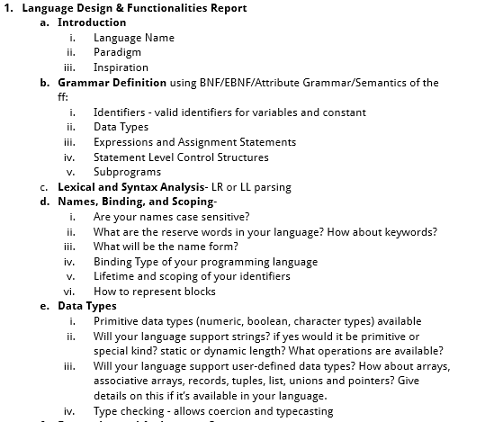

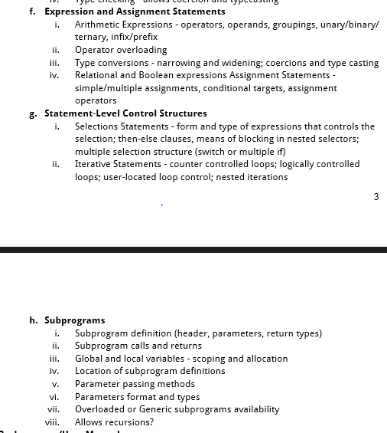

<NAME OF PROGRAMMING LANGUAGE>

CS 150 Machine Problem

User Manual

Gueco, Maria Rosario

Juntado, Marbille

Lenon, Mikaela Jun

Navarro, Gabriel Kelly

Arceo, Jahziel Rae

CS 150 HTWX